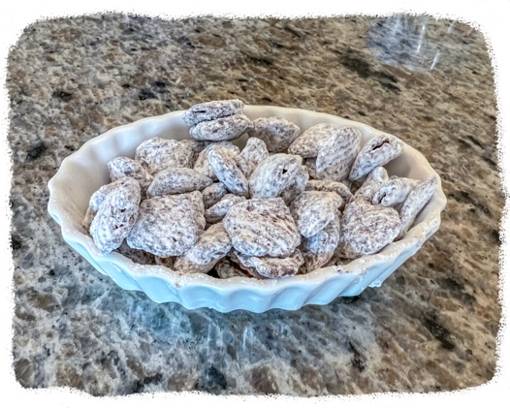
Puppy Chow candy mix

8 cups Crispix cereal (10oz. box)
1 cup semi-sweet chocolate chips
½ stick butter
½ cup peanut butter
2 cups powdered sugar

_____________________________

Melt chocolate chips, butter, and peanut butter together in double boiler.

Pour melted mixture over Crispix cereal; mix gently with spatula until cereal is evenly coated.

Put coated cereal into paper bag with powdered sugar; shake to coat cereal with sugar.

