Rhubarb Chiffon Pie
Rhubarb Mixture Ingredients:
1/2 to 2/3 cup Sugar
Orange Zest strip
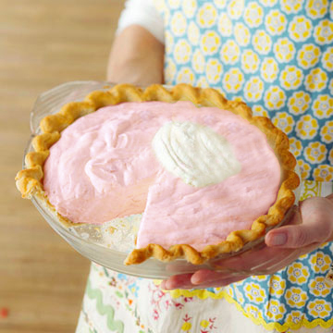
1/4 cup Water
3 cups Rhubarb in 1/2 inch pieces

Other Pie Ingredients:
1/4 cup Sugar
1/2 TBLS. Lemon Juice
1/4 cup Sugar
1 envelope Unflavored Gelatin
3/4 cup Water
2 Egg Whites
1/4 cup Sugar
1/2 cup Whipping Cream
1 9-inch Baked Pastry/Pie
Yield: 8 servings
In a medium saucepan, combine sugar, orange peel, and 1/4 cup water. Bring to boiling; add rhubarb. Reduce heat. Cover; simmer 5 minutes or till tender. Remove orange peel and drain off excess liquid through strainer. Set aside to cool.

In a large bowl stir together 1 ¼ cups cooled rhubarb mixture, ¼ cup sugar, and lemon juice. Let this mixture stand 30 minutes.

Meanwhile, in a small saucepan stir together ¼ cup sugar and the gelatin. Stir in the ¾ cup water; heat and stir till sugar and gelatin dissolve. Cool.

Stir the cooled gelatin mixture into the rhubarb mixture. Chill to the consistency of corn syrup, stirring occasionally. Remove from refrigerator. (rhubarb-gelatin mixture will continue to set)

Immediately begin beating the egg whites till soft peaks form. Gradually add ¼ cup sugar, beating till stiff peaks form.

When rhubarb mixture is partially set (the consistency of unbeaten egg whites) fold in the stiff-beaten egg whites.

Beat whipping cream until soft peaks form. Fold whipped cream into rhubarb mixture. Chill until mixture mounds when spooned.

Pile mixture into Baked Pastry Shell. Chill Pie 8 hours or till firm.

Serve with whipped cream and a fresh strawberry garnish, if desired.

