Traditional New Mexico Green Chile Stew

Yield: 6 servings
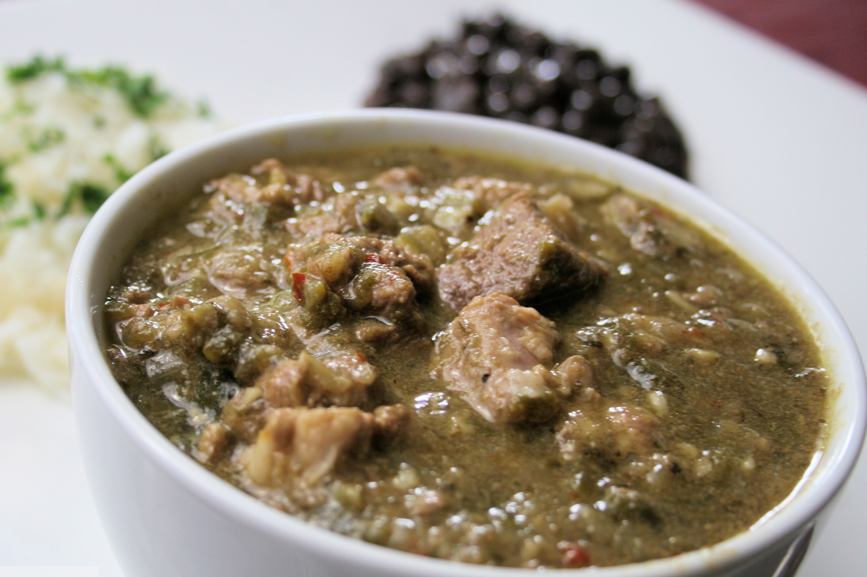
Cooking Time: Approximately 1 hour
Temperature: Medium, Low
• Freezes Well •
- 2 pounds pork or beef, cubed
- 3 cups potatoes
- ¼ cup flour
- 2 cups water
- 2 tablespoons shortening
- ½ teaspoon garlic powder
- 2 large onions, chopped
- 2 teaspoons salt
- 3 cups roasted, peeled and chopped New Mexico green chile*
- 1 cup chopped tomatoes (*Optional)

1. Dredge the meat in flour. Place the shortening in a heavy skillet and brown meat at medium heat. Place meat in a large stewing pot.
2. Sauté the onions in the remaining shortening and add to stewing pot.

3. Add all remaining ingredients to stewing pot and simmer at low heat for 1 hour.
* Varied amounts may be used.
____________________________________________________________
Recipe found at: https://iamnm.com/new-mexican-green-chile-stew-recipe/

